what's the weather like ?
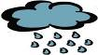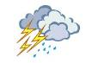
1 yianr 2 unsny 3 tymors 4 oulcdy
………………………. ………………….. ………………….. ……………………..
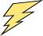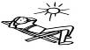
5 igthenlnig 6 ramw 7 Yowns 8 r eezfnig . ……………………. ……………………… ………………………… …………………………. ………………….. ………………………………
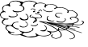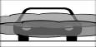
9 indwy 10 oggyf 11 Oilbnig oth 12 owbianr
………………………. ………………………… ………………….. ………………………….
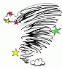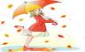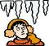
13 ornatdo 14 untherd 15 oolc 16ciy
………………… ……………………………. ………………………. ………………………..
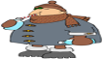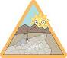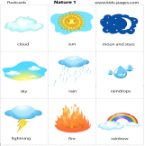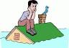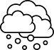
17 oldc 18 uoghtdr 19 earlc 20 ooldf 21 oth 22 liah
………………………. ……………………….. ………………………. ……………………… ……………………… ……………………….
Hot........................
Flood…………………
Freezing………………Cool…………
Sunny......................Drought........
Rainy......................Snowy............
Stormy......................Cold.............
Boiling hot..............
Rainbow.................-
Tornado.................Hail................
Clear......................
Cloudy.................
Icy...........................Warm............. Thunder........Foggy......................
Lightening ........................
Sunny.............................

Unscramble the words and then write the number of the picture next to the correct
Word
Answer these questions about the weather and then ask a partner
- What’s the weather like in your country i. ……………………… n the summer?.....................................................................................
- What’s the weather like in winter?........................................................................................................................
- What’s your favourite season?.................................................................................................................................
- Why?..........................................................................................................................................................................
- What was the weather like yesterday?........................................................................................................................
- What’s the weather like today?...............................................................................................................................
- What season is usually hot and sunny?....................................................................................................................
- What season is usually cool and rainy?...................................................................................................................
- Do you usually have snowy winters?..........................................................................................................................
- Do you like cold and snowy weather?.......................................................................................................................
- When is your birthday?..........................................................................................................................
- What was the weather like on your last birthday?.............................................................................................

