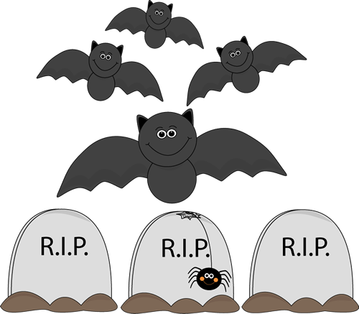
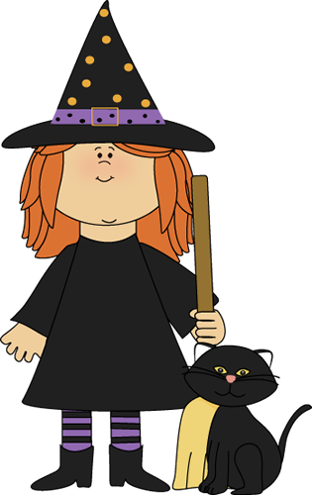
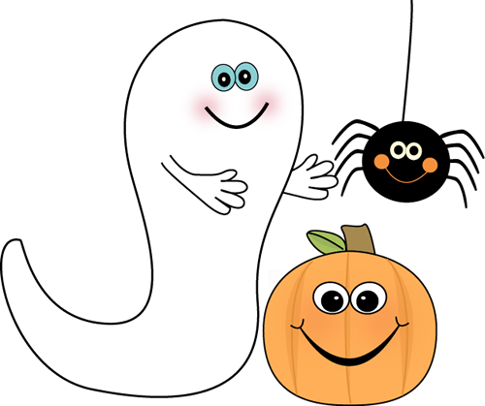
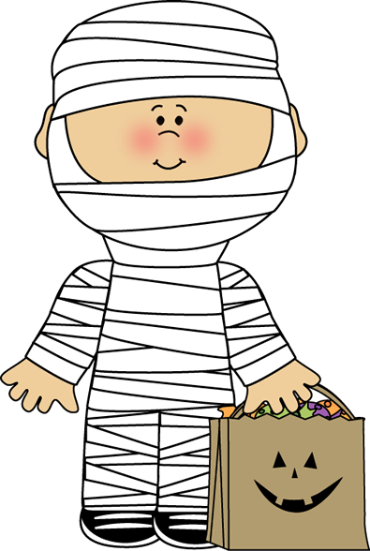




I go
You go
He goes
She goes
It goes
We go
You go
They go
I watch
You watch
He watches
She watches
It watches
We watch
You watch
They watch
I study
You study
He studies
She studies
It studies
We study
You study
They study

Fill in the missing letters

I wash
You _ _ _ _
He _ _ _ _ _ _
She _ _ _ _ _ _
It _ _ _ _ _ _
We wash
You _ _ _ _
They _ _ _ _
I do
You _ _
He _ _ _ _
She _ _ _ _
It _ _ _ _
We do
You _ _
They _ _
I sleep
You _ _ _ _ _
He _ _ _ _ _ _
She _ _ _ _ _ _
It _ _ _ _ _ _
We sleep
You _ _ _ _ _
They _ _ _ _ _

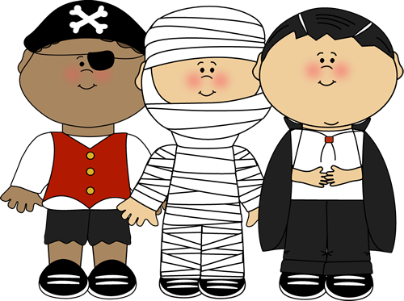
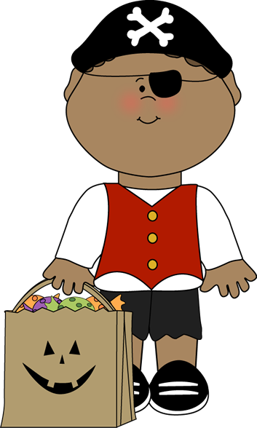
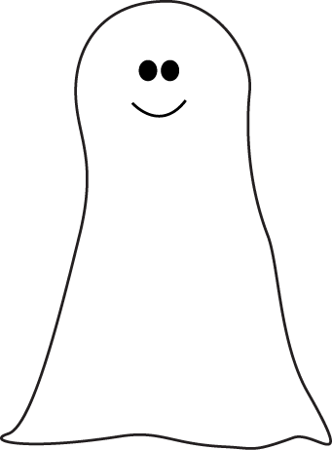
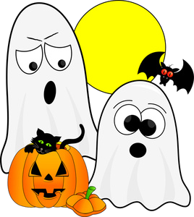
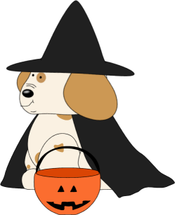
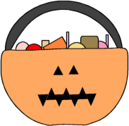

I don’t go
You don’t go
He doesn’t go
She doesn’t go
It doesn’t go
We don’t go
You don’t go
They don’t go
I don’t watch
You don’t watch
He doesn’t watch
She doesn’t watch
It doesn’t watch
We don’t watch
You don’t watch
They don’t watch
I don’t study
You don’t study
He doesn’t study
She doesn’t study
It doesn’t study
We don’t study
You don’t study
They don’t study

Fill in the missing letters

I don’t sleep
You _ _ _ _ _ _ _ _ _
He _ _ _ _ _ _ _ _ _ _ _
She _ _ _ _ _ _ _ _ _ _ _
It _ _ _ _ _ _ _ _ _ _ _
We don’t sleep
You _ _ _ _ _ _ _ _ _
They _ _ _ _ _ _ _ _ _

I don’t cry
You _ _ _ _ _ _ _
He _ _ _ _ _ _ _ _ _
She _ _ _ _ _ _ _ _ _
It _ _ _ _ _ _ _ _ _
We don’t cry
You _ _ _ _ _ _ _
They _ _ _ _ _ _ _
I don’t brush
You _ _ _ _ _ _ _ _ _
He _ _ _ _ _ _ _ _ _ _ _
She _ _ _ _ _ _ _ _ _ _ _
It _ _ _ _ _ _ _ _ _ _ _
We don’t bush
You _ _ _ _ _ _ _ _ _
They _ _ _ _ _ _ _ _ _


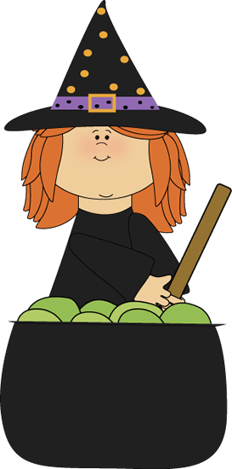
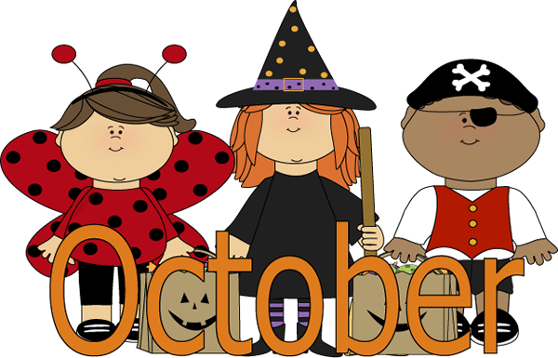
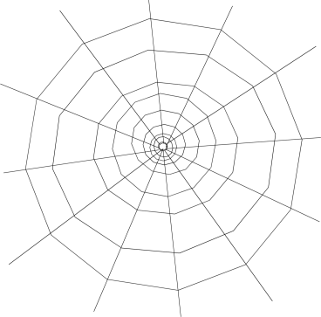
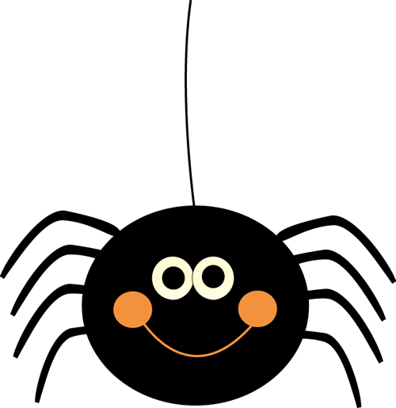
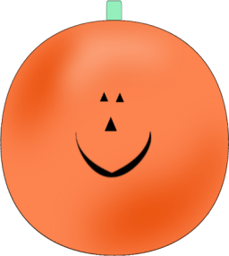
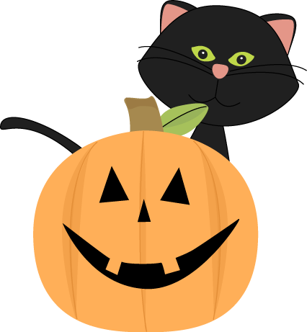
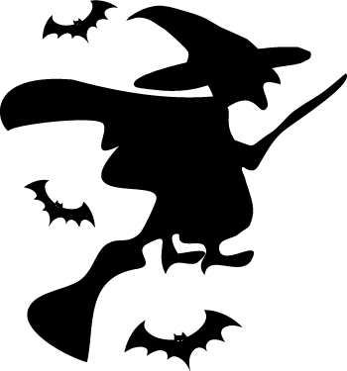

Do I go?
Do you go?
Does he go?
Does she go?
Does it go?
Do we go
Do you go?
Do they go?
Do I watch?
Do you watch?
Does he watch?
Does she watch?
Does it watch?
Do we watch?
Do you watch?
Do they watch?
Do I study?
Do you study?
Does he study?
Does she study?
Does it study?
Do we study?
Do you study?
Do they study?

Fill in the missing letters

Do I eat?
_ _ you _ _ _?
_ _ _ _ he _ _ _?
_ _ _ _ she _ _ _?
Do we eat?
_ _ you _ _ _?
_ _ they _ _ _?
Do I catch?
_ _ you _ _ _ _ _?
_ _ _ _ he _ _ _ _ _?
_ _ _ _ she _ _ _ _ _?
_ _ _ _ it _ _ _ _ _?
Do we catch?
_ _ you _ _ _ _ _ ?
_ _ they _ _ _ _ _?
Do I fly?
_ _ you _ _ _?
_ _ _ _ he _ _ _?
_ _ _ _ she _ _ _?
_ _ _ _ it _ _ _ ?
Do we fly?
_ _ you _ _ _?
_ _ they _ _ _?

