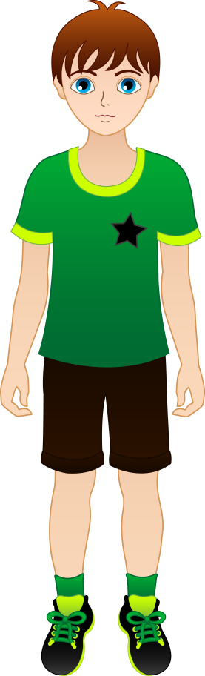
Read the text about Lucas Benson.

My full name is Lucas Benson. I’m eleven years old and I live in Manchester. It’s a big city in England. I go to Parrs Wood High School. It’s a very modern school.
I’m very tall and very thin. I’ve got straight brown hair and blue eyes.
I’m a nice boy and I’ve got lots of friends. I’m very active because I play football after school and basketball on Saturdays.
I live with my mother, Laura, and my grandparents. I haven’t got any brothers or sisters and my father is in Canada. My mother is a veterinary assistant. She likes animals very much. We’ve got two dogs at home. My grandmother stays at home but my grandfather is a police office. He’s got a dangerous job.
I like helping my mother with the animals and my dogs. I also like sports and going to the cinema on Sundays.
A. Match the columns:
1. Benson...  2. He isn’t...  3. He is...  4. His father...  5. He plays...  6. His grandmother... | a) football after school.  b) friendly.  c) hasn’t got a job.  d) short.  e) is his surname.  f) doesn’t live with him. | 1. ____  2.____  3.____  4.____  5.____  6.____

B.Answer the questions about the text:
1. How old is Lucas?
2. Where is Manchester?
3. What’s Lucas like?
4. What’s his mother job?
5. Has Lucas got any pets?
6. What are his favourite hobbies?

C. Answer the questions. Write complete sentences (possessive case):
1. Whose ball is this?(Lucas) It’s Lucas’s ball.
2. Whose house is this?(Mr Forester) It’s ______________________________
3. Whose dogs are these? (Laura) They are__________________________
4. Whose school is this?(the children) It’s _____________________________

D. Fill in the blanks with the correct possessive pronoun: MINE-HIS-HERS-THEIRS
1. This is Lucas’s school. It’s _____________.
2. Sandy: “Are these your dogs, Laura?”
Laura: “yes, they are ___________.”
3. Look, it’s Mr and Mrs Forester’s house! It’s ____________.
4. This is Laura’s car. It’s _____________.

E. Write the correct form of the TO HAVE and TO BE verbs:
Hi! I_______ Peter, Lucas’s cousin. We _______ at the same school. We _________ lots of friends. I __________ eleven too. I ____________ brown hair and blue eyes like Lucas.
I ___________(not) blonde hair and brown eyes. I ___________ a sister. She _________ thirteen. She ____________ brown hair too but she ___________(not) blue eyes.
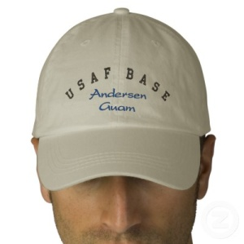
F. Describe Barry. Write sentences using the information given:
1. Barry/tall - _______________________________________________________
2. he/dark hair - _____________________________________________________
3. his hair/short- _____________________________________________________
4. Barry/a base cap- ___________________________________________________

