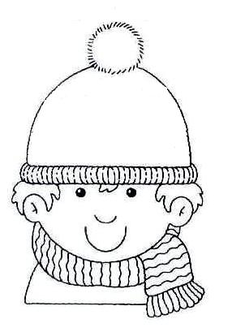

I’m Sam. I’m eleven years old and I live in the countryside. We get up really early, at half past five. After breakfast I help my father - We have a barn and a lot of animals. At twelve o’clock we have lunch and my lessons start at quarter to one. I don’t go to school, I learn at home. My mother is my teacher and we study 5 hour every day. I finish my lessons at quarter to six and then I watch TV or play computer games. At seven o’clock I do my homework. We have dinner at half past eight. I go to bed at half past nine.

**READ AND DRAW THE HANDS**



**GET UP**



**HAVE LUNCH**

**TRUE OR FALSE**



Sam studies during the morning True False

He studies at home with her sister True False

He watches TV at seven o’clock True False

He works with his father everyday True False

**START LESSONS**

His mother is a teacher True False



He has dinner at half past nine True False

**ANSWER THE QUESTIONS**

What time does he wake up?

_____________________________________________

**FINISH LESSONS**

What does he do during the morning?

_____________________________________________

What time does he start his lessons?

_____________________________________________

Does he go to school? Who is his teacher?

**HOMEWORK**

_____________________________________________



What does he do after his lessons?

_____________________________________________

What time does he do his homework?

_____________________________________________

What time do they have dinner?

**HAVE DINNER**

_____________________________________________