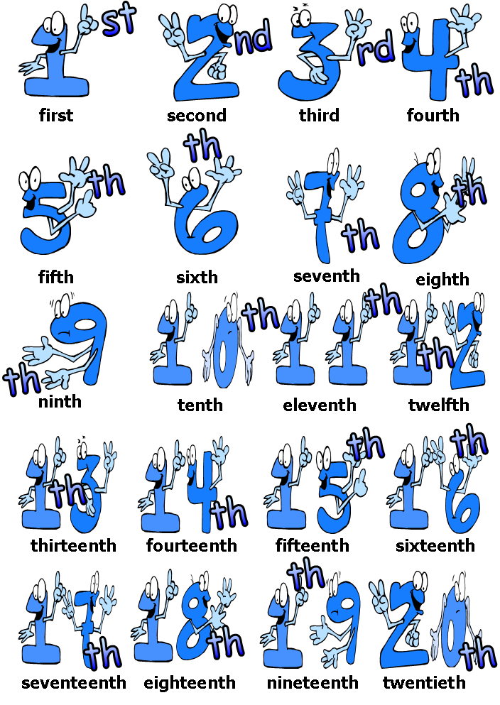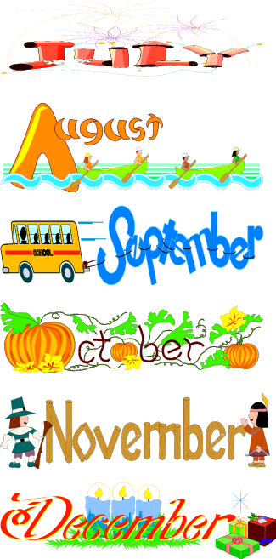

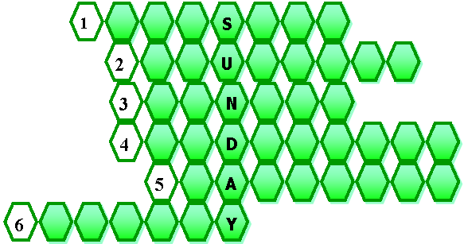

**1. Find out the missing letters to complete the days of the week.**

**1**

**S**

**2**

**U**

**3**

**N**

**4**

**D**

**5**

**A**

**6**

**Y**

**1**

**S**

**2**

**U**

**3**

**N**

**4**

**D**

**5**

**A**

**6**

**Y**

**3. Look at the ordinal numbers. Write them in full.**

* **13th ___________________________**
* **5th ____________________________**
* **12th ___________________________**
* **22nd ___________________________**
* **31st ___________________________**
* **10th ___________________________**
* **17th ___________________________**

**2. Complete the sentences with the correct month of the year missing.**

* **Christmas Eve is in _____________________________**
* **Autumn begins on the 21st ______________________**
* **The first month of the year is ____________________**
* **Valentine´s Day is in ___________________________**
* **Spring begins in ______________________________**
* **Summer begins in ____________________________**
* **Halloween is on ______________________________**

**3. Look at these dates. Write them in full.**

* **1900 ________________________________________________________________________________**
* **2007 ________________________________________________________________________________**
* **1526 ________________________________________________________________________________**
* **1800 ________________________________________________________________________________**
* **2000 ________________________________________________________________________________**
* **2105 ________________________________________________________________________________**